How to go on NSAC’s Facebook Live Sunday Service

Step 1  Click this link and a window should pop up.  https://www.facebook.com/northshorealliancechurch/  Your screen should look like this photo: | 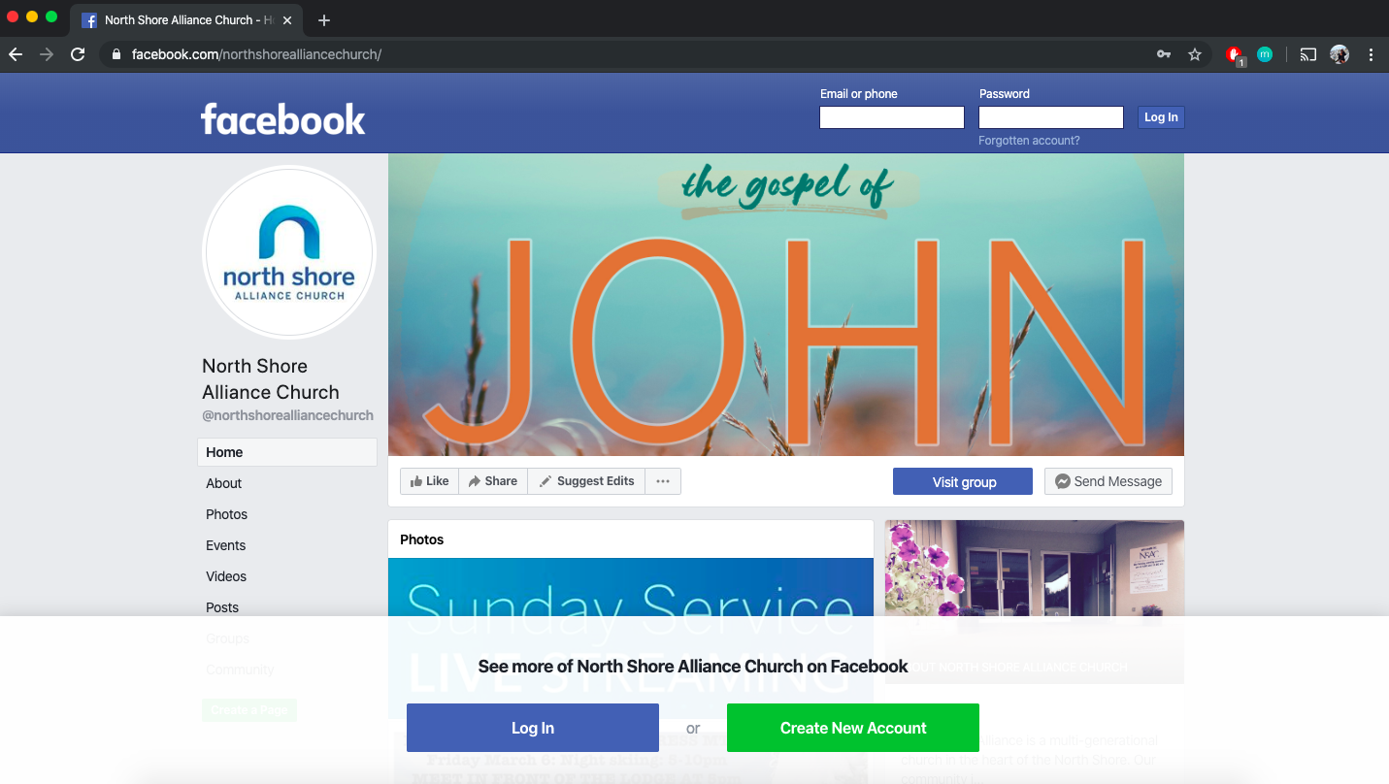
Step 2  Something may pop up on your screen that looks like this:  If this pops up, click “Not now” as circled in this photo. | 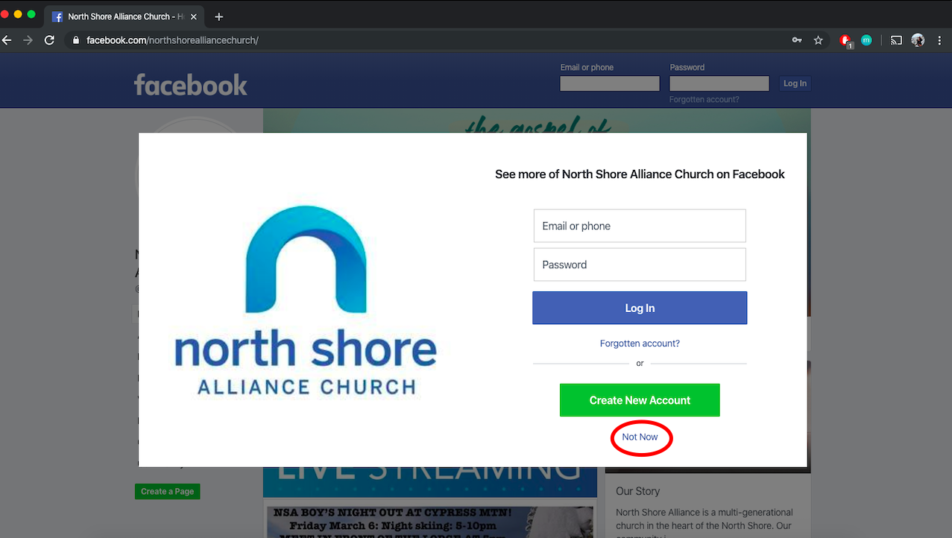
Step 3  Scroll down the page just a little bit. Look for the “Posts” as seen in the picture.  Your screen will not have President David Hearn on it, but will have our Sunday service. Click the first post that you see. | 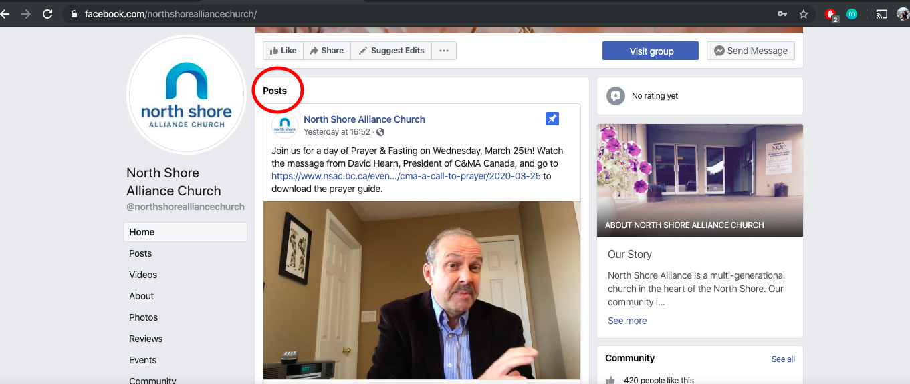
Step 4  Check to see if the video that you are seeing is not an old video. Check to see if it has “LIVE” in the top left corner of the video. | 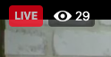
Step 5
Enjoy the Service!

